Q. What is git?

A. git is a version control system.

Q. Why we need version control system?

A. 1.

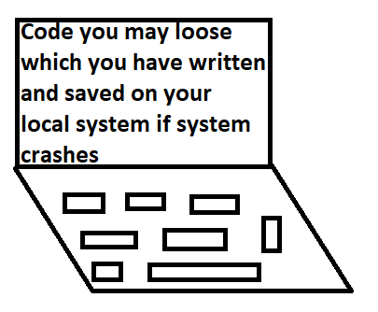

2.

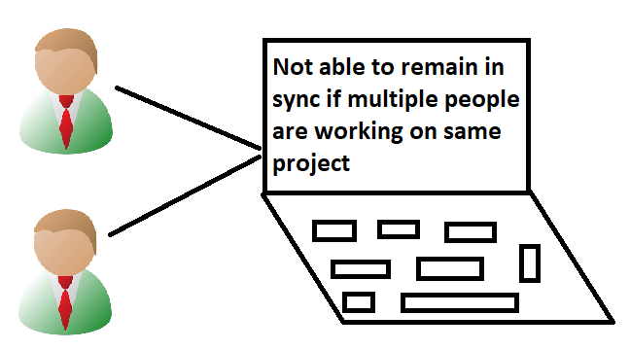

3.

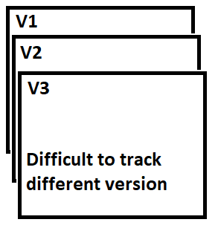

**Solution**

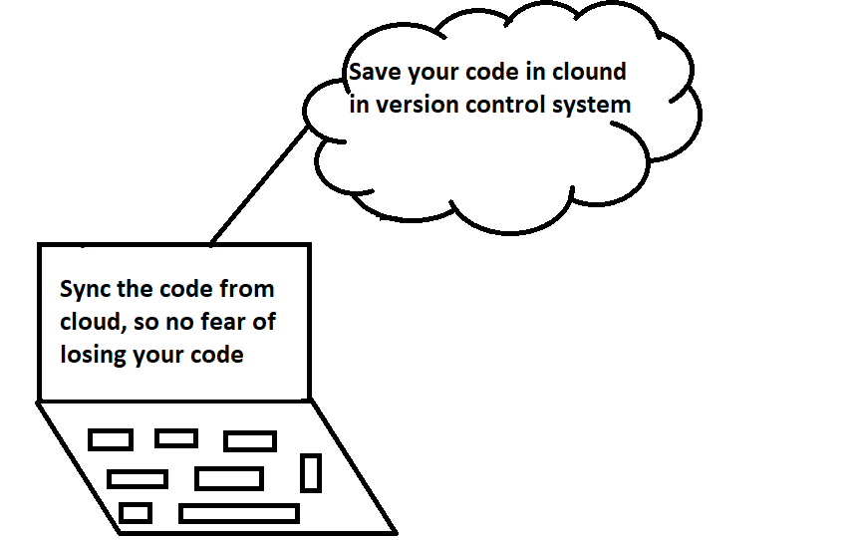

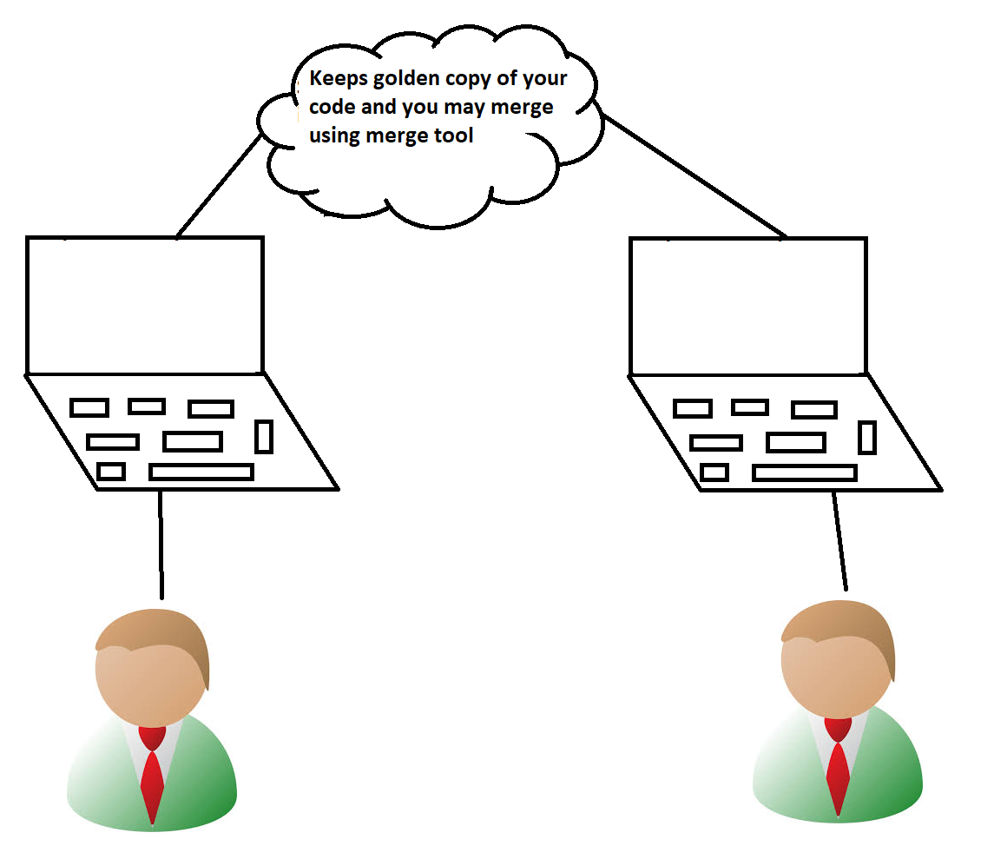

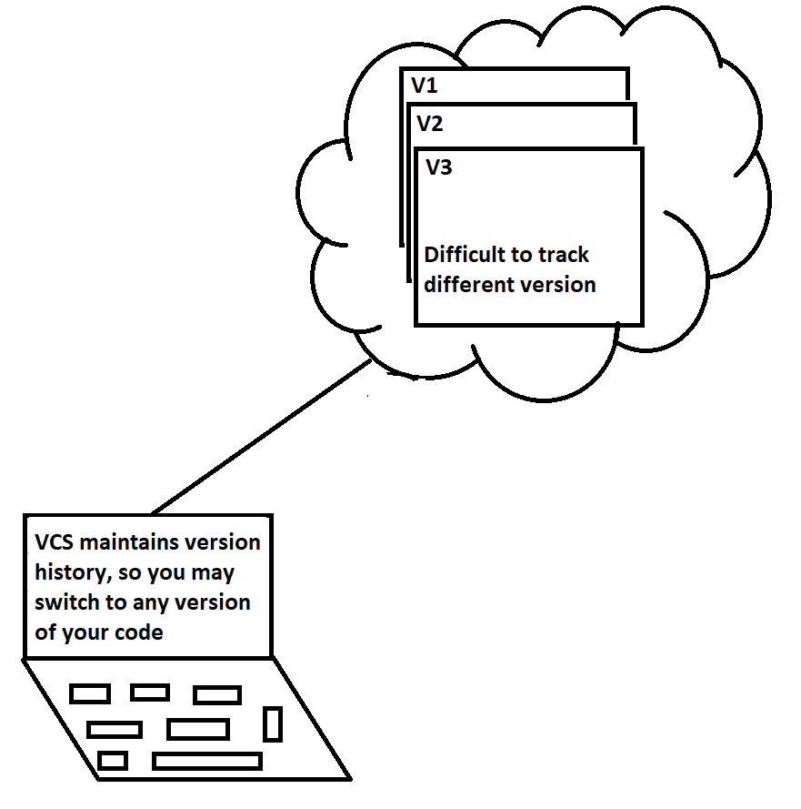

**Different version control system available in the market**



**Git is by far most used version control system, Why?**

1. **It is distributed version control system.**
2. **Github, most used website for code hosting is powered by git.**

**What is Git Hub?**

1. **It is a website which allows you to store your code in cloud.**
2. **It is a full version control system powered by git.**

**Create an account on github**

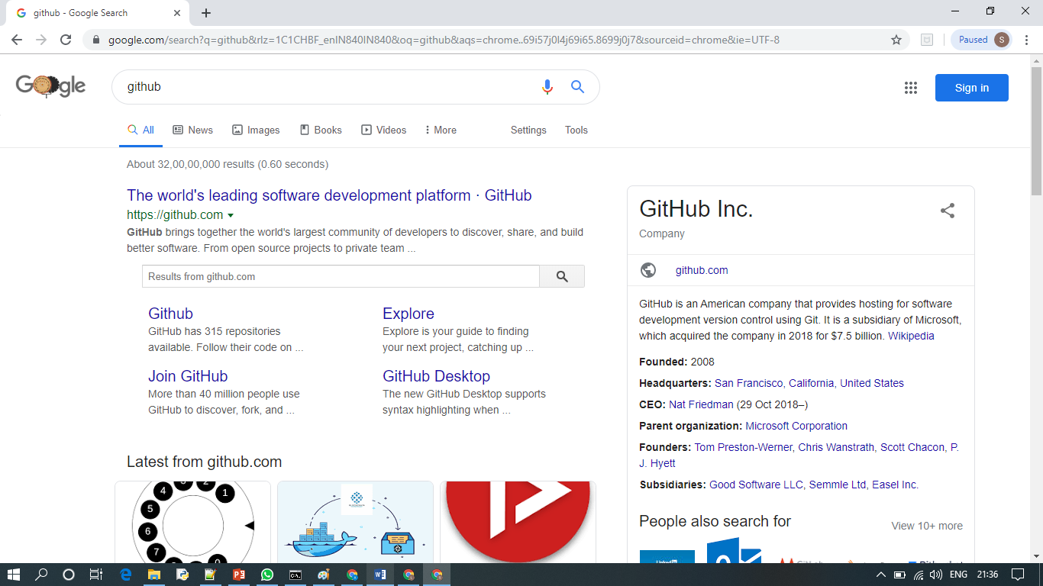

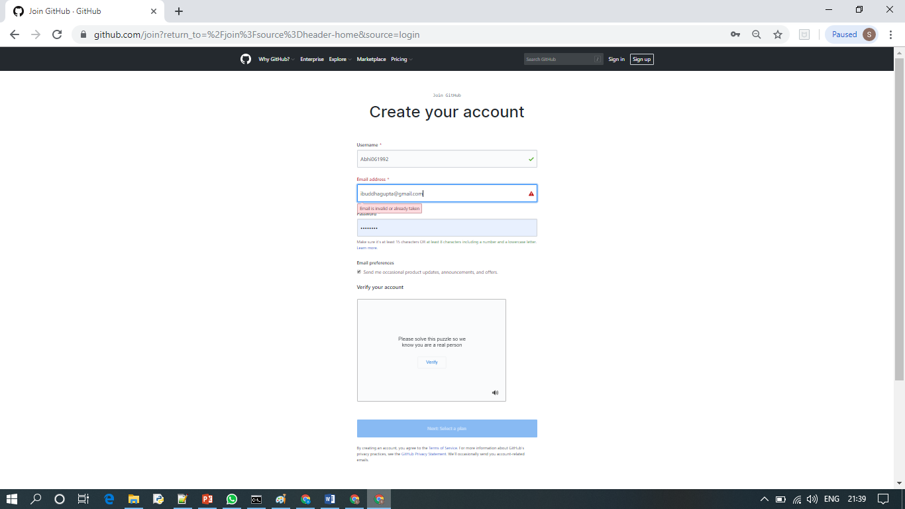

1. **Create new repository**

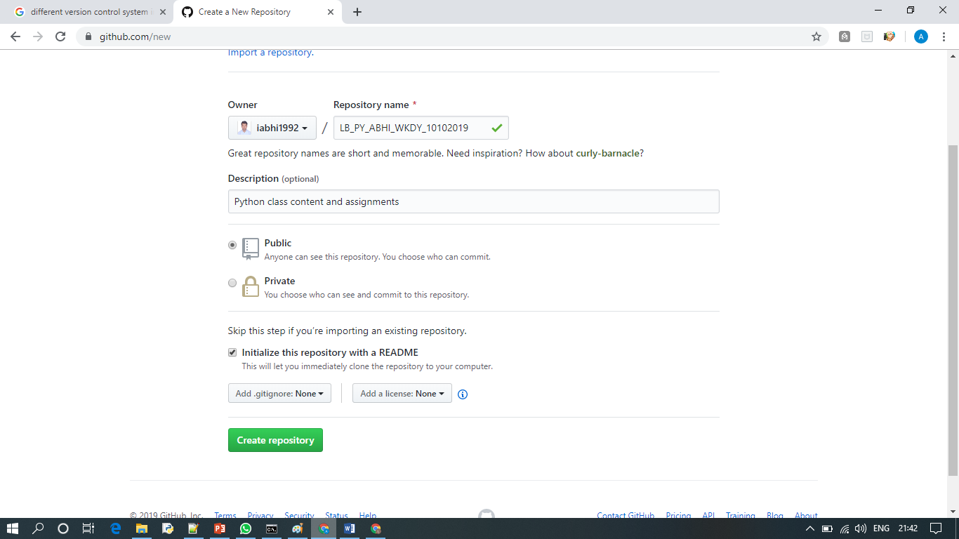

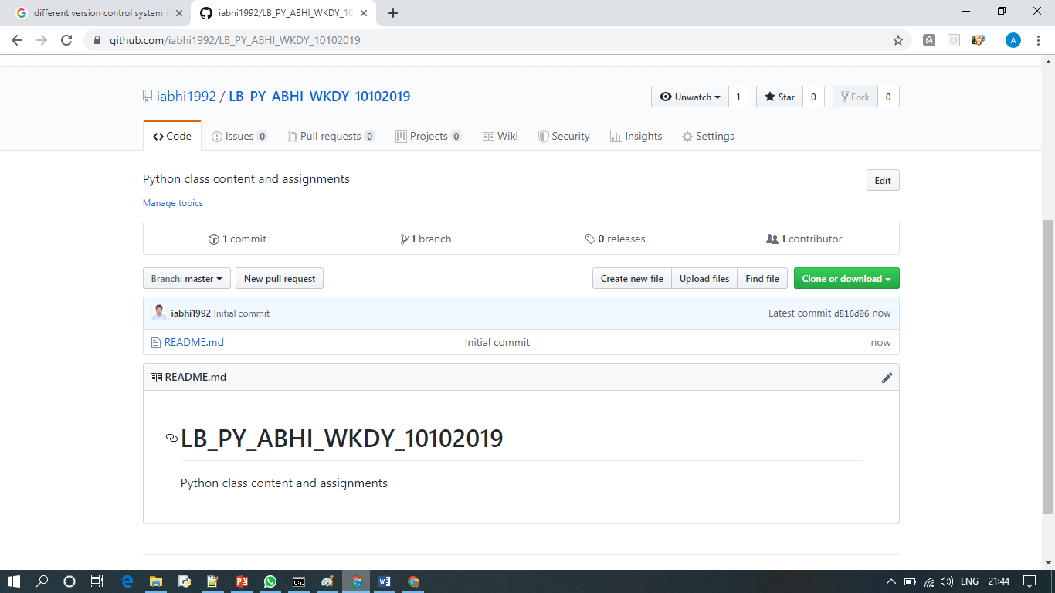

**Must know**

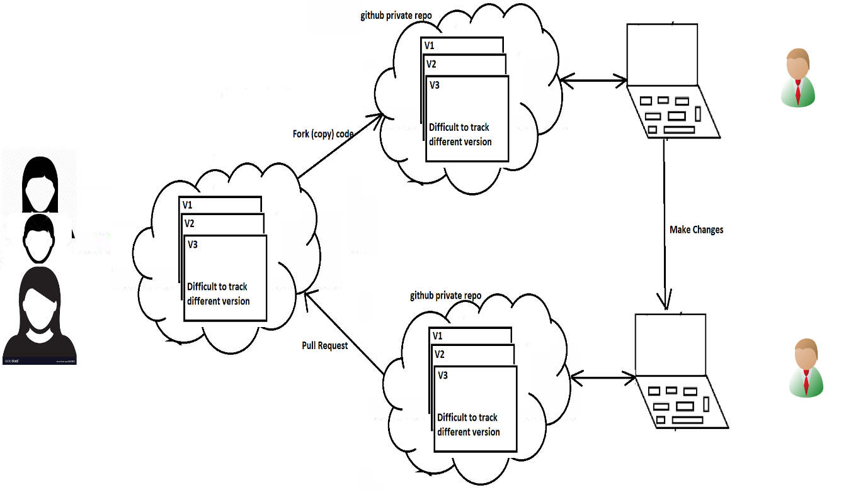

Issues

Wiki

Pulse

Graph

**Installing git on windows**

**1.**

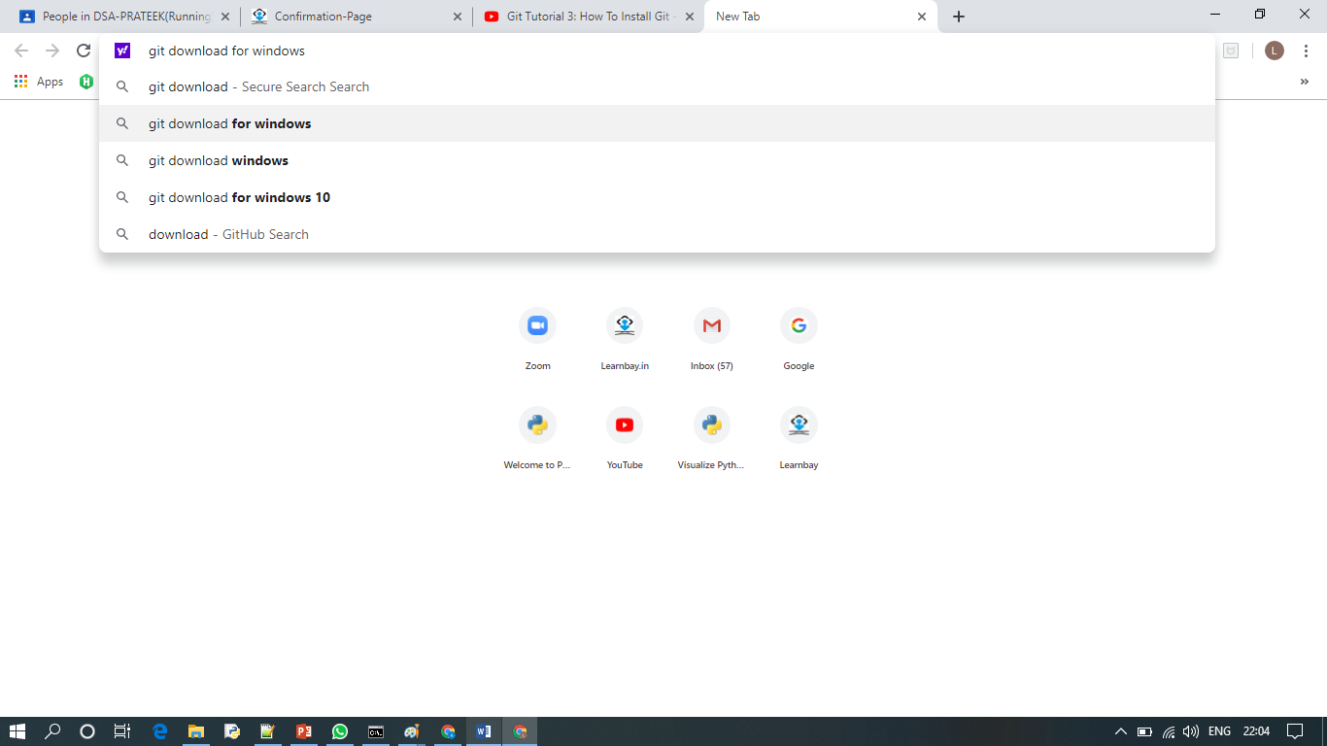

**2.**

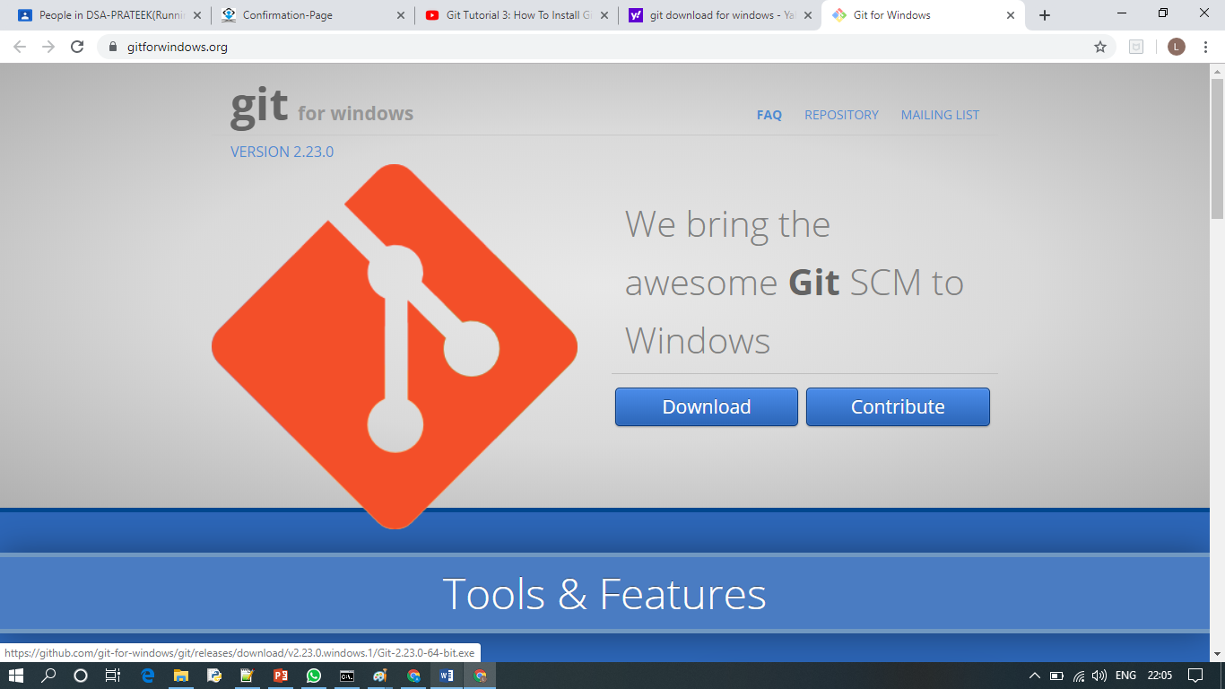

**3.**

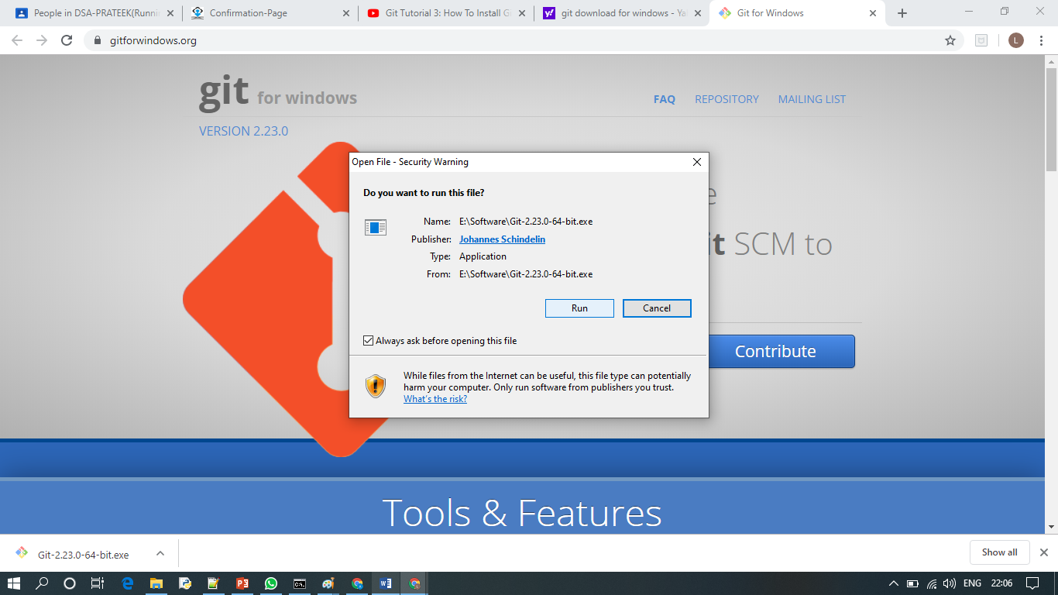

**4.**

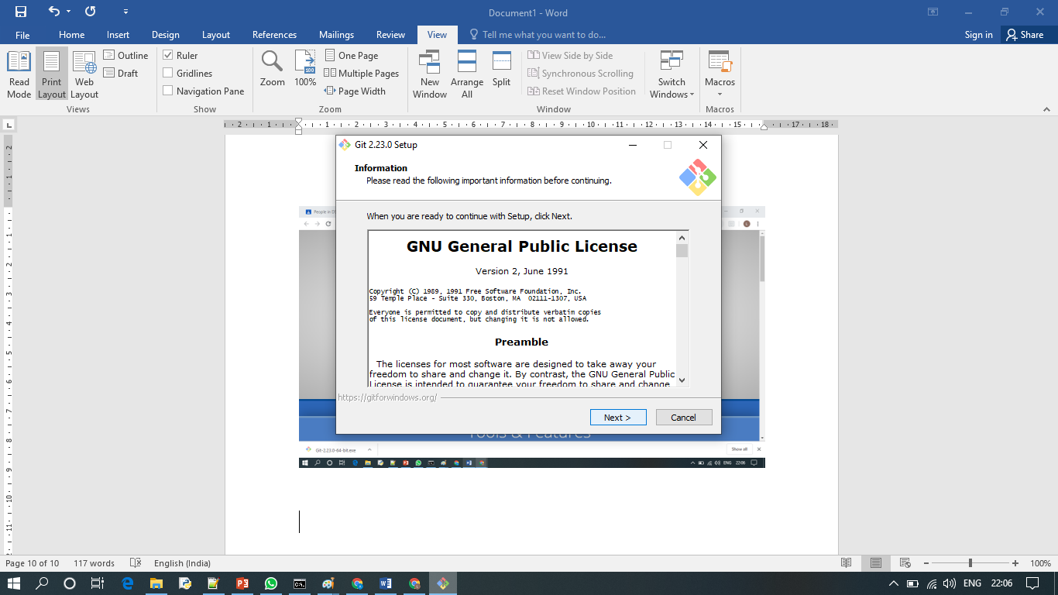

**After installation type git command from git bash**

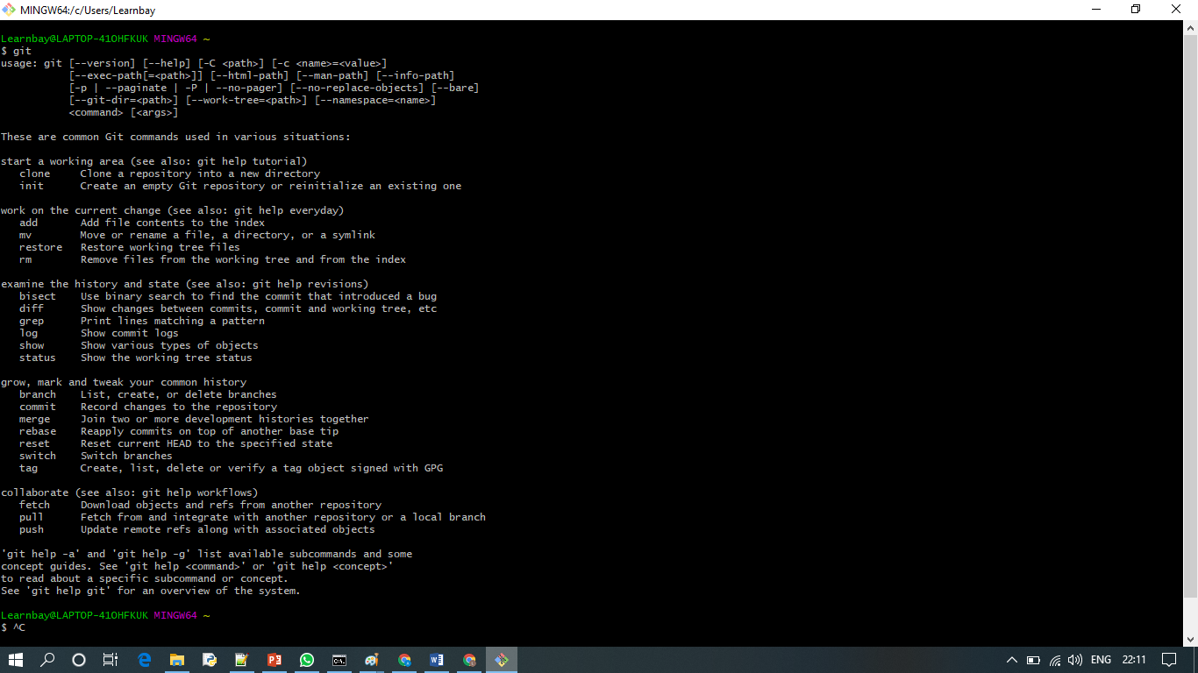

**Launching git bash from cmd**

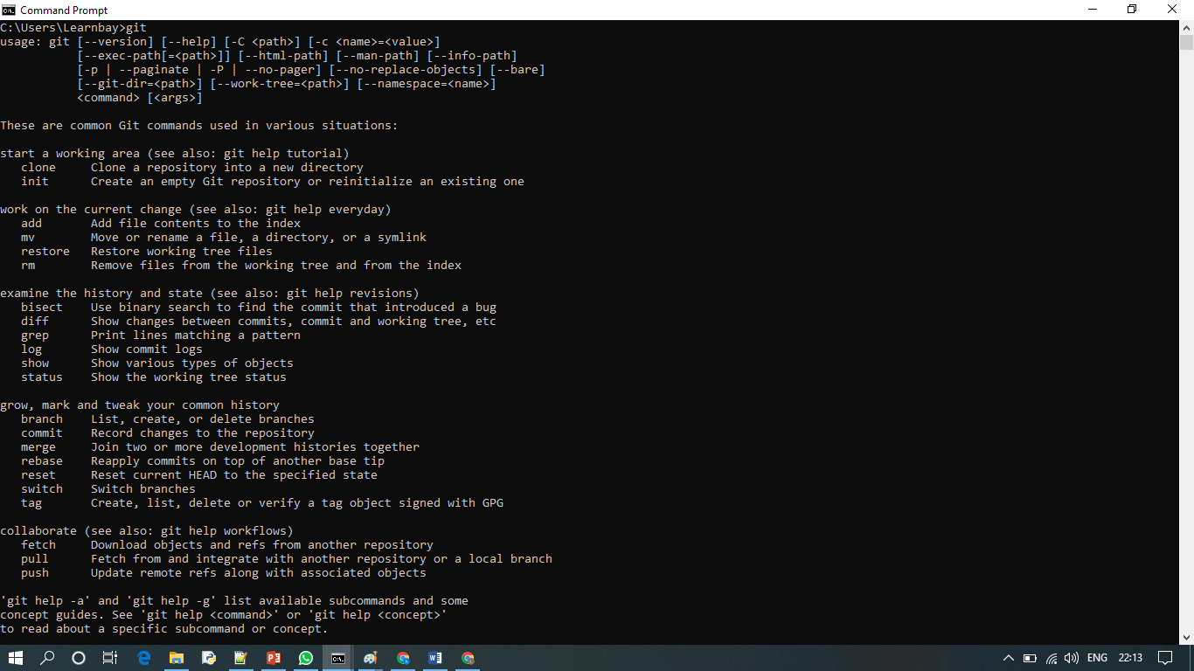

**Cloning the repo**

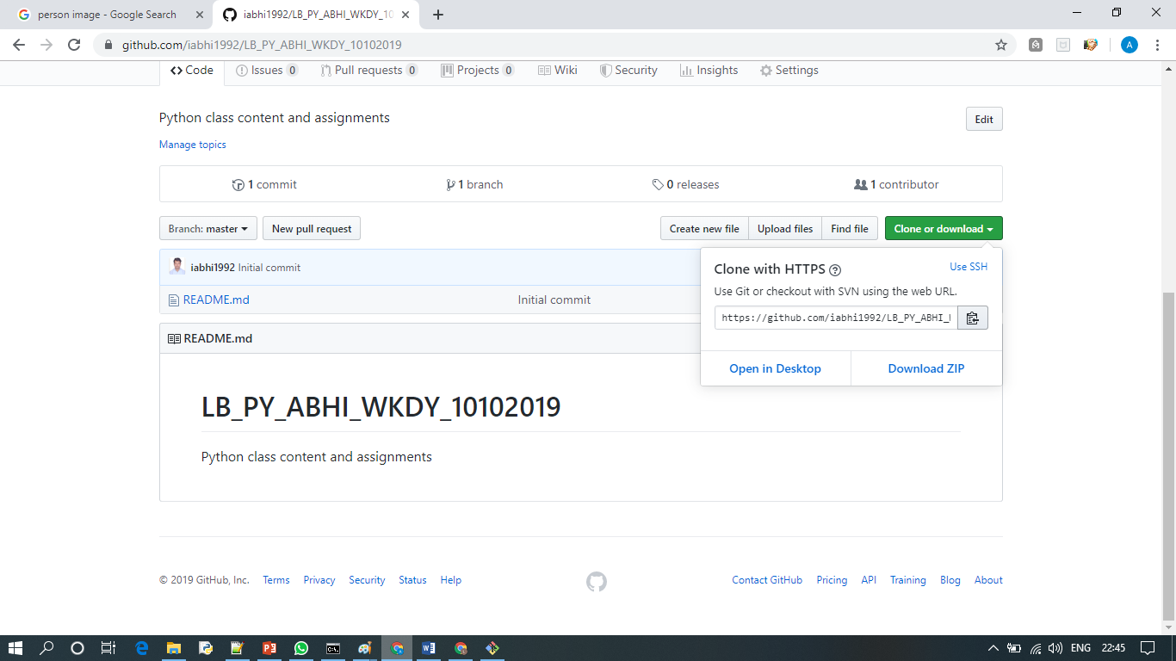

**git clone <copied link from git hub>**

**then ls and cd to folder**

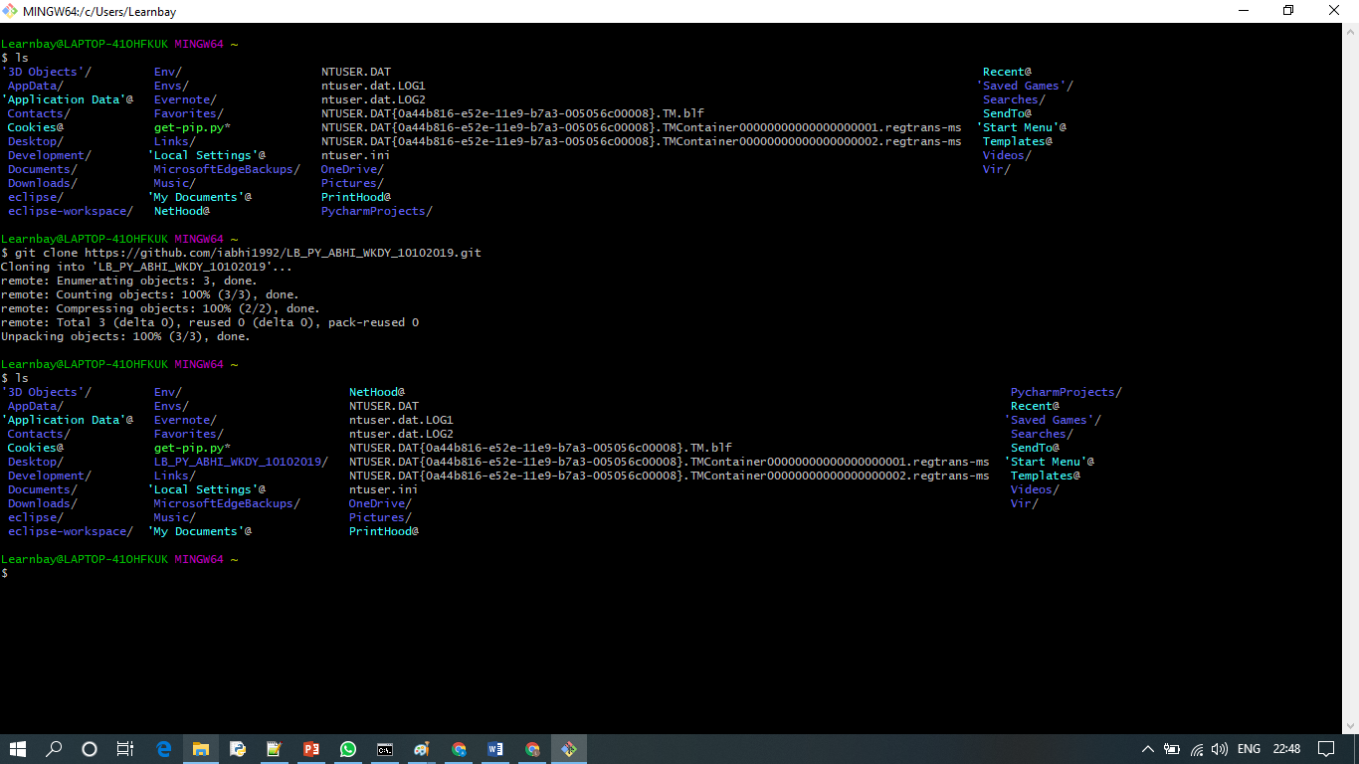

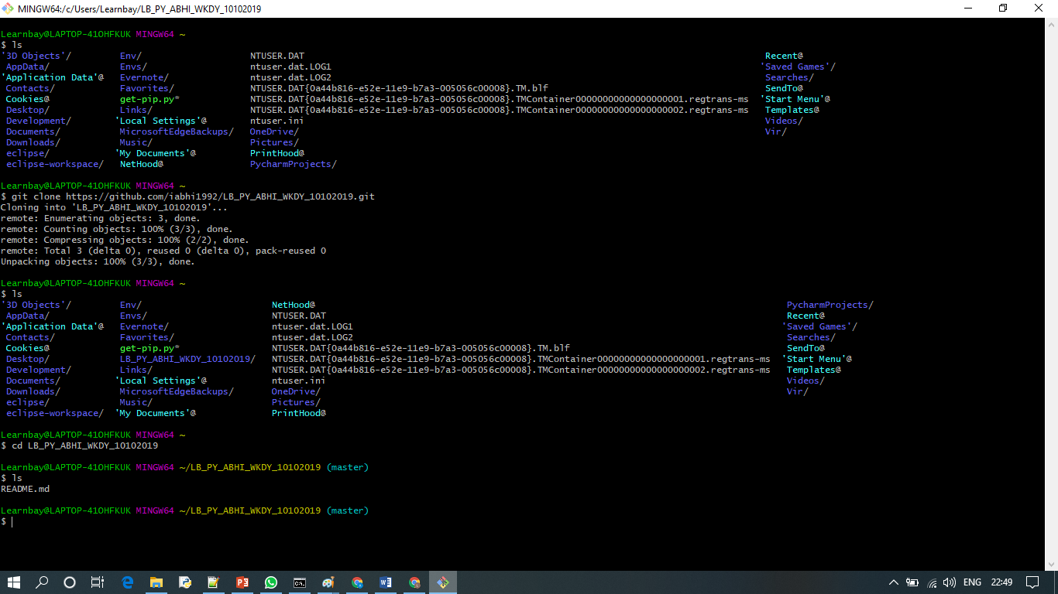

**git status**

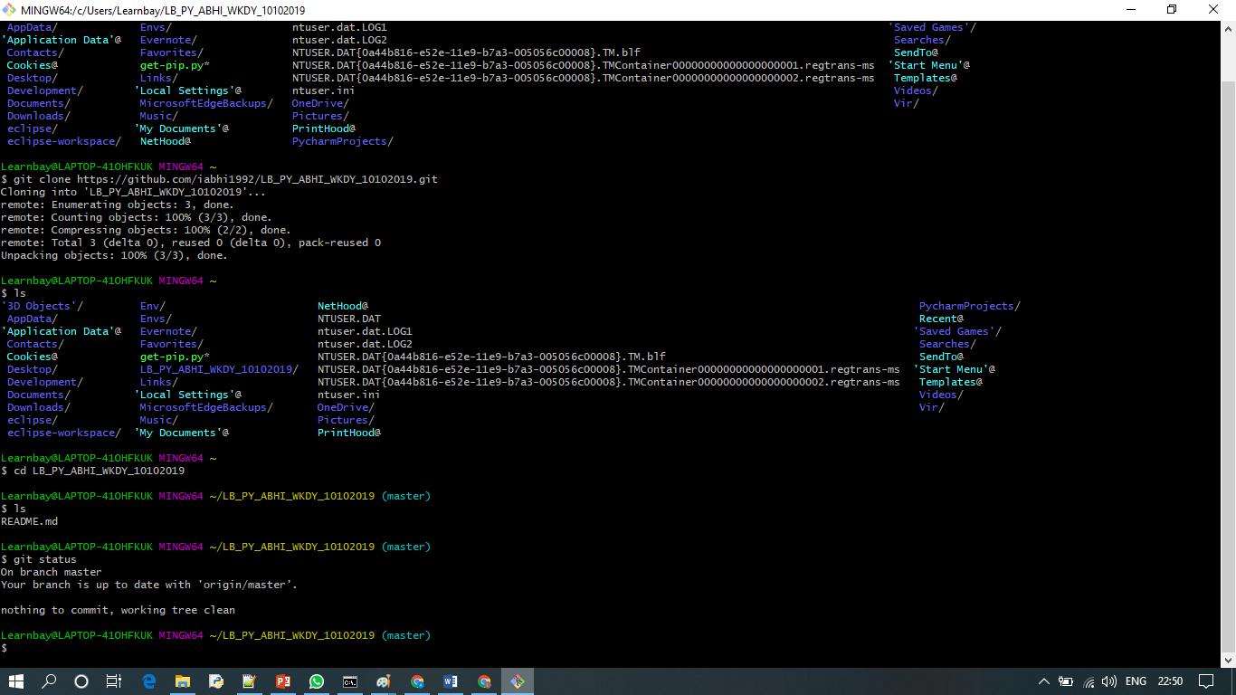

**git add <file name> - - to move file to staging area**

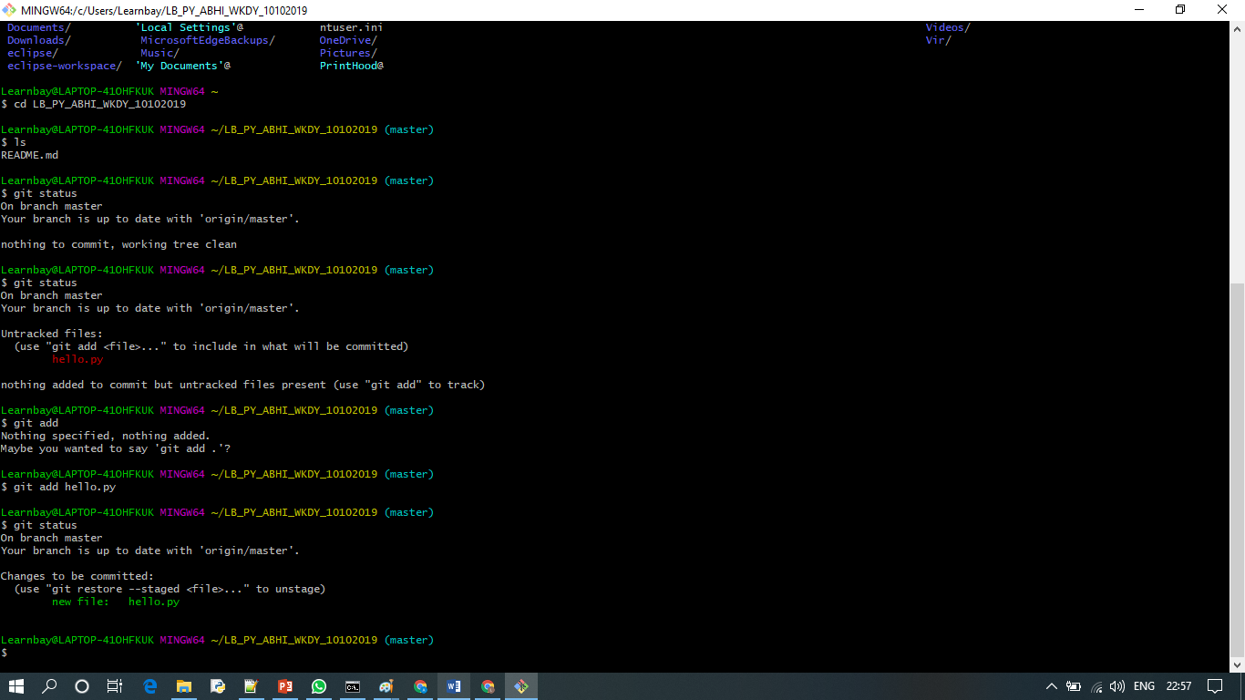

**git status**

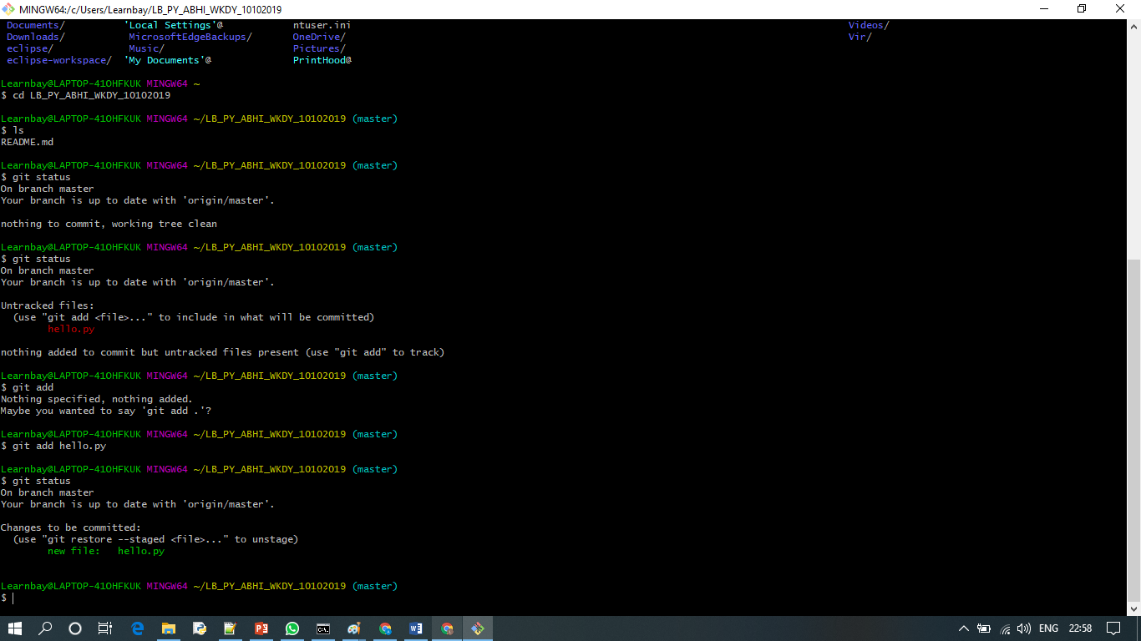

git commit -m 'first time hello.py'

* Add changes to local VCS. Still code is not pushed to cloud

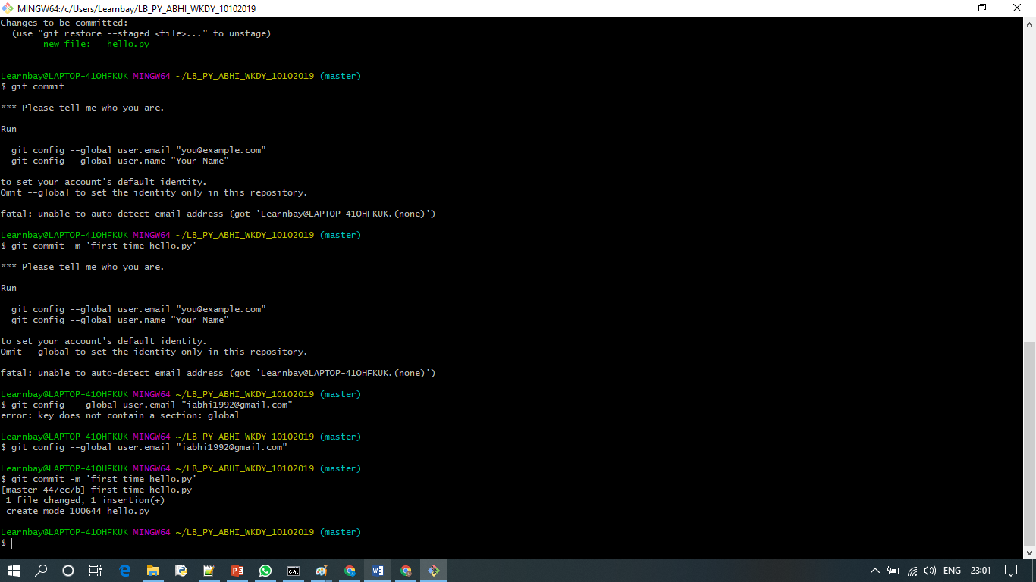

**git log – log of all commit history**

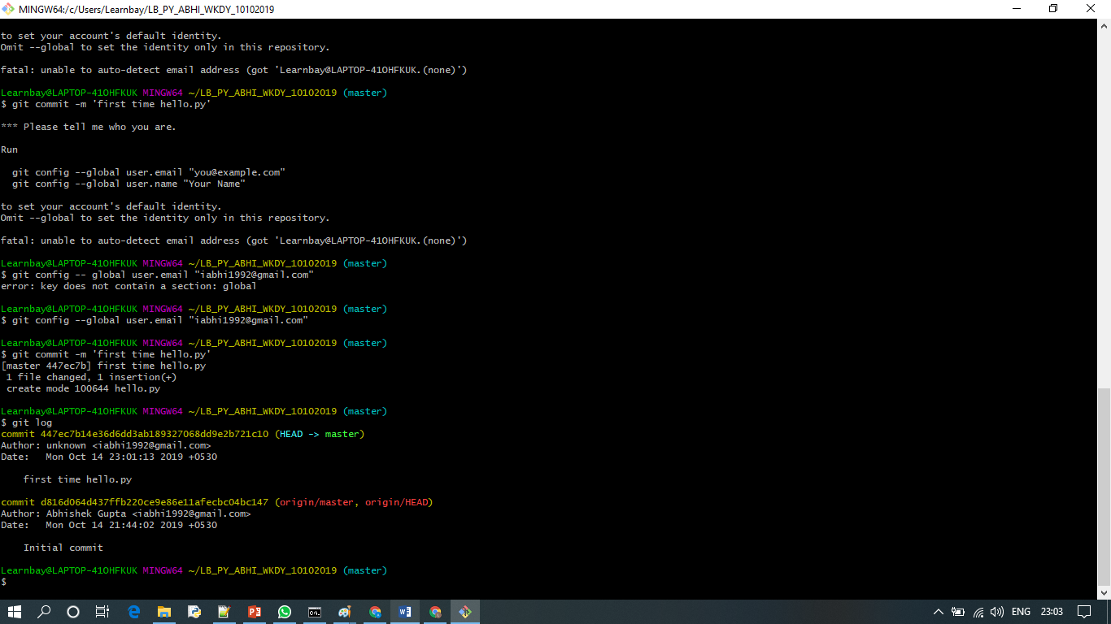

**Git status**

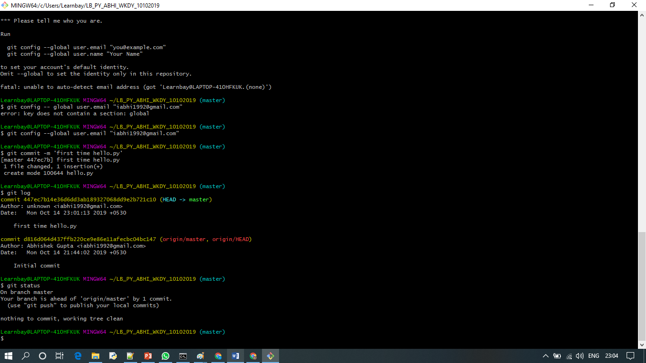

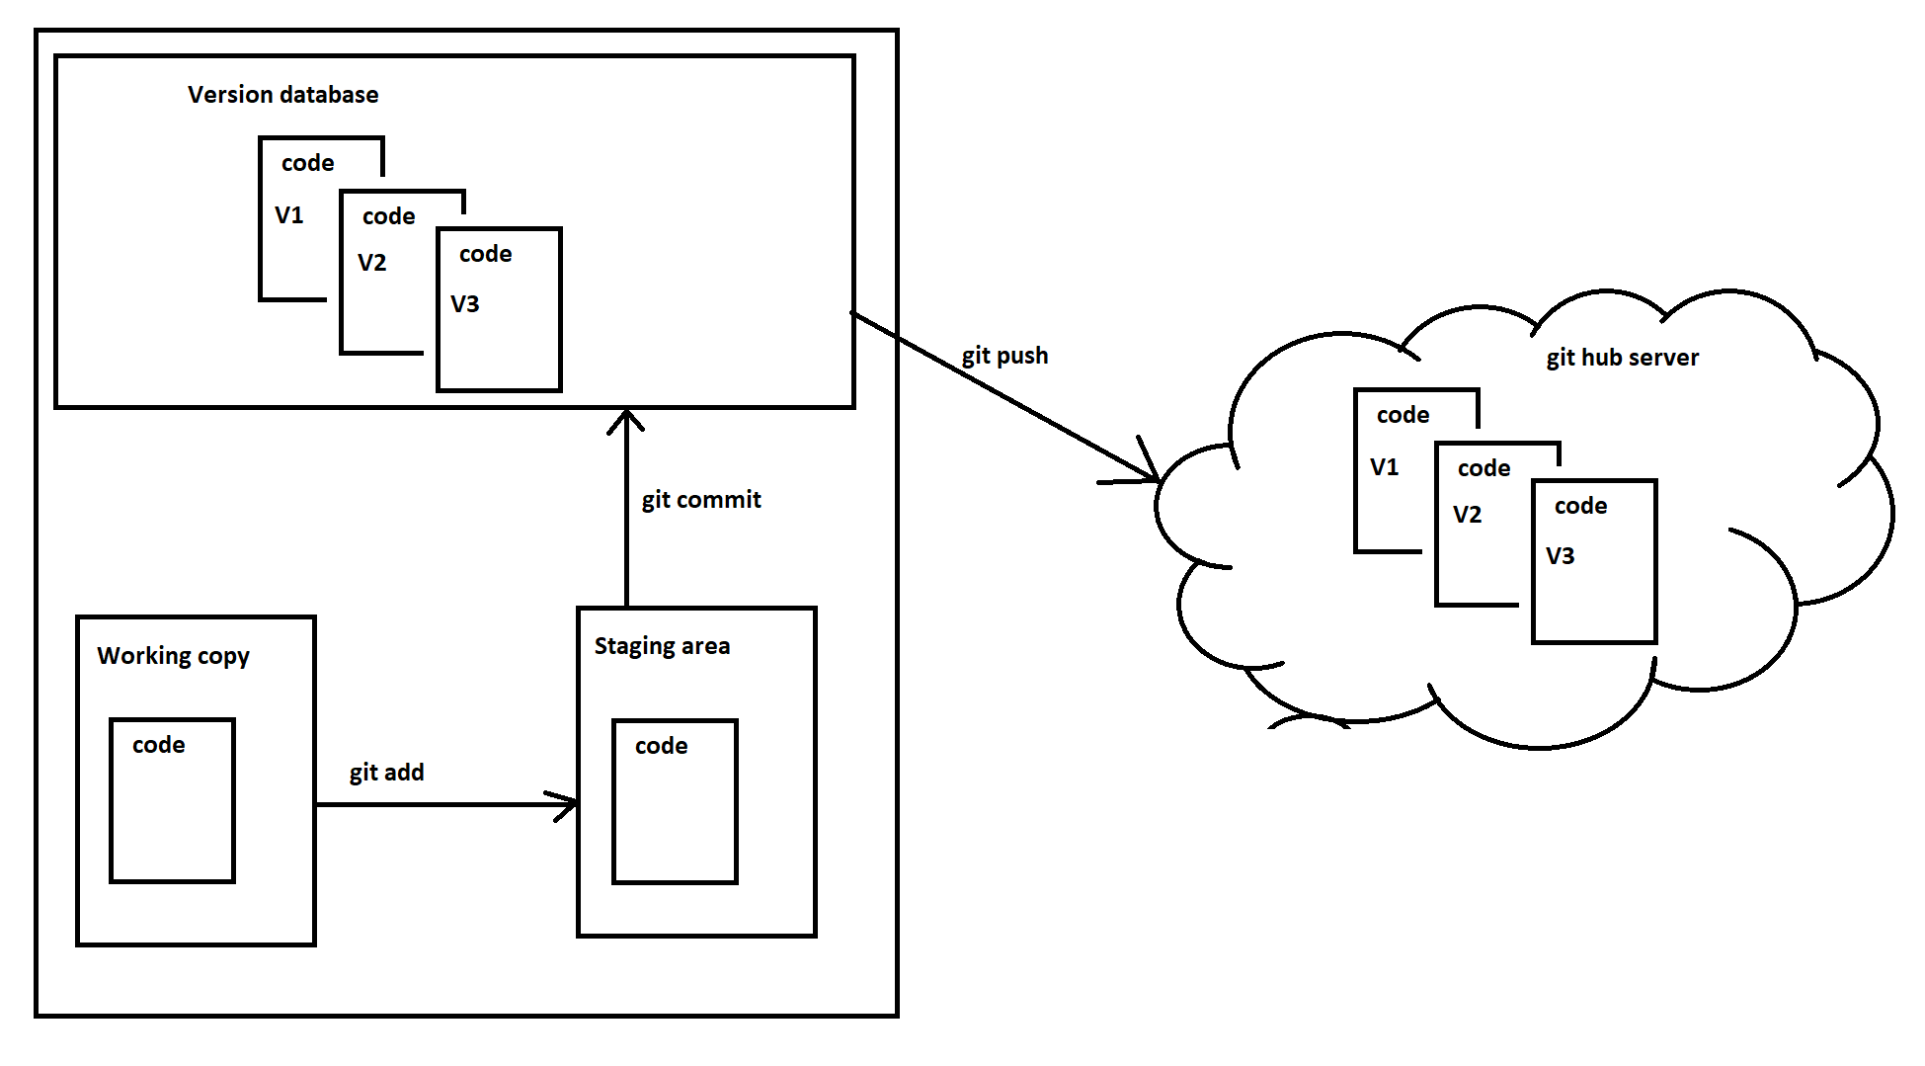

**Undoing changes -** git restore hello.py

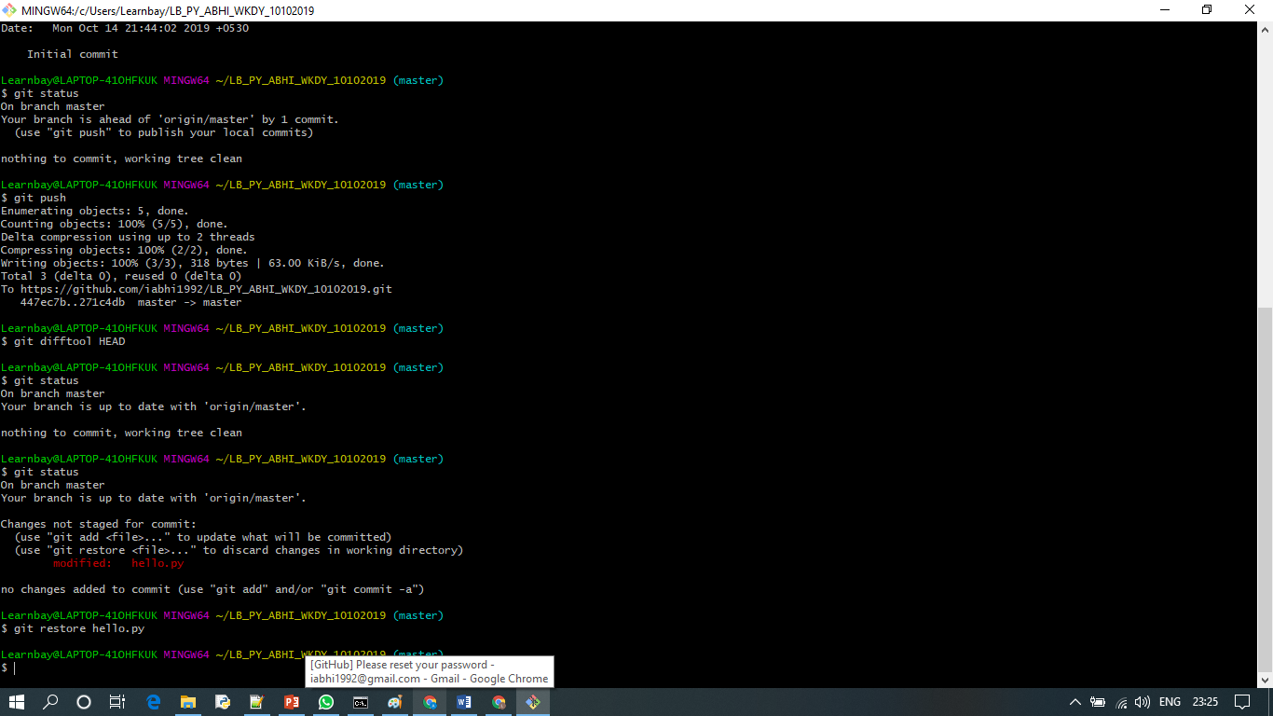

**git checkout -- <filename> 🡪 to undo changes to current file**

**git checkout -- . 🡪 to undo changes to all file.**

**Reverting commited changes:-**

**git revert <commit id>**

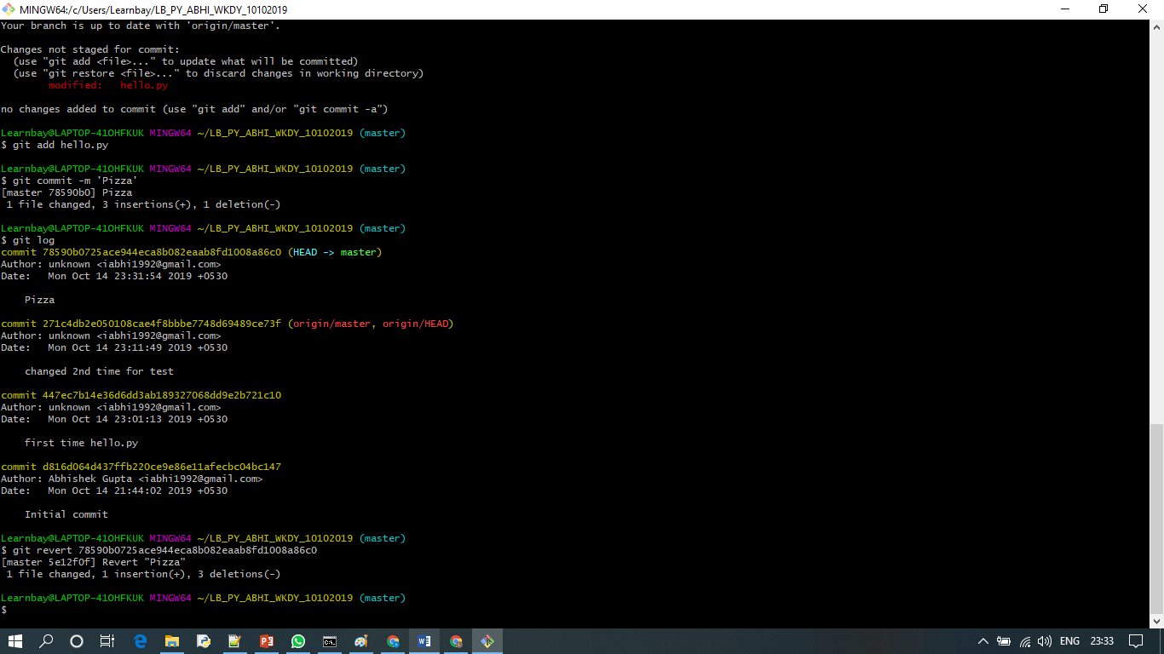

**Git reset –hard <commit id>**

**Branching**

**Git branch – shows current branch**

**Git branch <new branch name> - creates new branch**

**Git checkout <branch name> - switches to different branch**

**After making changes – add, commit and push**

**Merging two branches**

**Git checkout <master branch>**

**Get merge <child branch>**